**QCI Details**

**Aadhar Card**

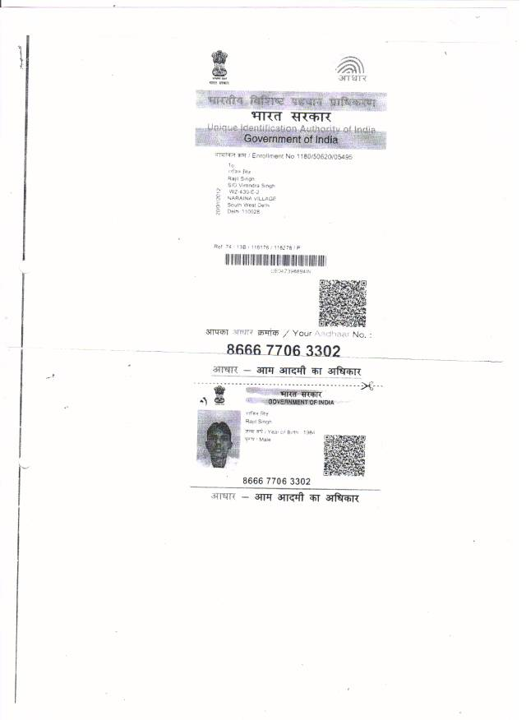

**QCI Details**

**Certificate**

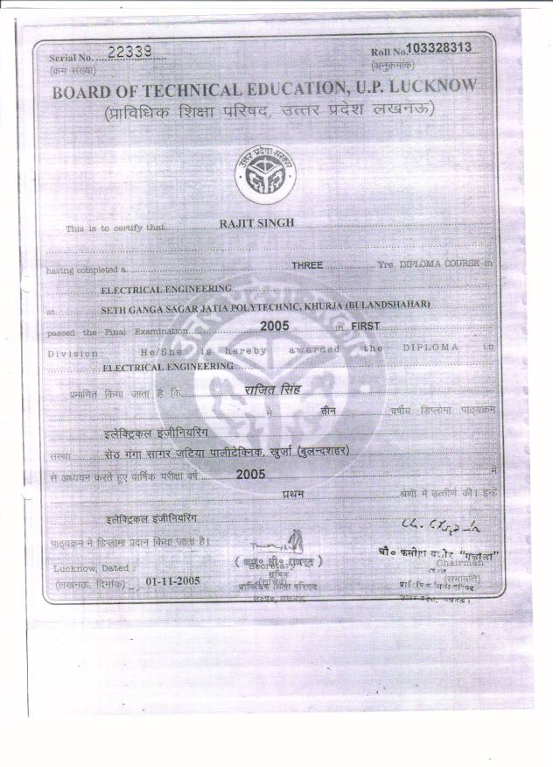

**QCI Details**

**Confirmation Letter**

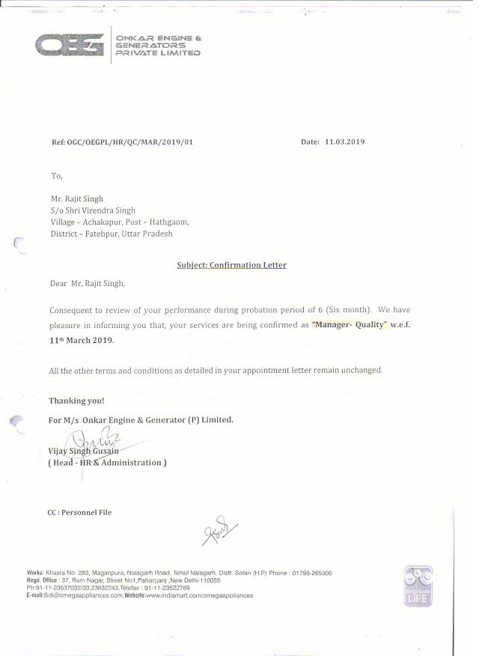

**QCI Details**

**Appointment Letter Pg 1**

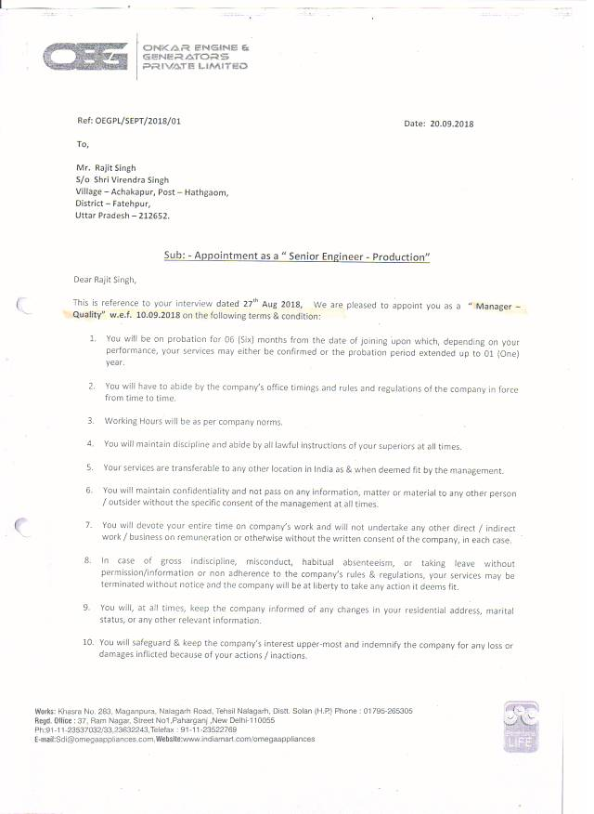

**QCI Details**

**Appointment Letter Pg 2**

